Daniel Halpin, S00199340 – Website Project

Introduction

Description of website and its purpose and the intended audience:

Website is a information source for COVID-19, lists current statistics and shows prevention practices.

The intended audience is anyone looking for basic information on COVID-19.

GitHub – must be included in order to mark your web project

GitHub URL to open your website on a browser

<https://danielh55irl.github.io/Web-Design-Project/index.html>

URL of your GitHub Repository

<https://github.com/DanielH55IRL/Web-Design-Project>

Original Mock-up Sketch of Website home page

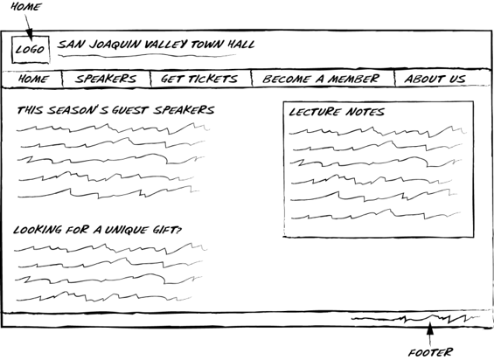

Website Described

Page 1 – described the purpose of the page and where you got your information and images from:

Introduction to what the website is about - COVID-19.

Information from WHO and HSE.

Images from Public Domain on pixabay.com.

Image URL’s:

Favicon: <https://pixabay.com/illustrations/covid-corona-coronavirus-virus-4948866/>

Image 1: <https://pixabay.com/illustrations/virus-coronavirus-sars-cov-2-flash-4915859/>

Image 2: <https://pixabay.com/illustrations/covid-corona-coronavirus-virus-4948866/>

Page 2 - described the purpose of the page and where you got your information and images from:

Lists the major symptoms and causes of COVID-19. Gives latest statistics from Department of Health. Shows a map with county by county cases and statistics (Map required in project checklist).

Information from HSE and Department of Health.

Images from Public Domain on pixabay.com.

Image URL’s:

Favicon: <https://pixabay.com/illustrations/covid-corona-coronavirus-virus-4948866/>

Image 1: <https://pixabay.com/illustrations/virus-coronavirus-sars-cov-2-flash-4915859/>

Map URL: <https://geohive.maps.arcgis.com/apps/opsdashboard/index.html#/29dc1fec79164c179d18d8e53df82e96>

Page 3 – described the purpose of the page and where you got your information and images from

Lists the basic measures to help prevent spread of COVID-19.

Information from HSE.

Image URL’s:

Favicon: <https://pixabay.com/illustrations/covid-corona-coronavirus-virus-4948866/>

Image 1: <https://pixabay.com/illustrations/virus-coronavirus-sars-cov-2-flash-4915859/>

Image 2(Background Image: <https://pixabay.com/illustrations/physical-distancing-social-distancing-4987002/>

Page 4 – described the purpose of the page and where you got your information and images from

Lists more sources of information form Official Sources. Video (part of checklist) showing more prevention tips from YouTube by Department of Health. Contact form which goes to required URL for forms.

Information gathered from various listed sources on page.

Image URL’s:

Favicon: <https://pixabay.com/illustrations/covid-corona-coronavirus-virus-4948866/>

Image 1: <https://pixabay.com/illustrations/virus-coronavirus-sars-cov-2-flash-4915859/>

HTML5 Validation Results for each Webpage

Page 1 – –Validations result (with the majority of the errors resolved):

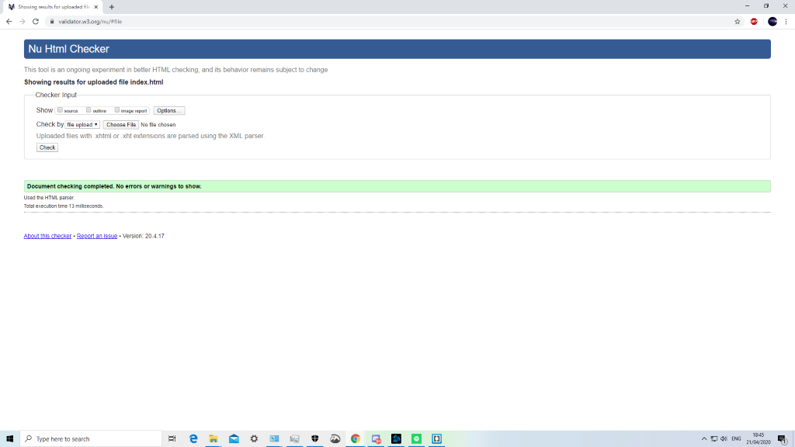

Page 2 – Validation result:

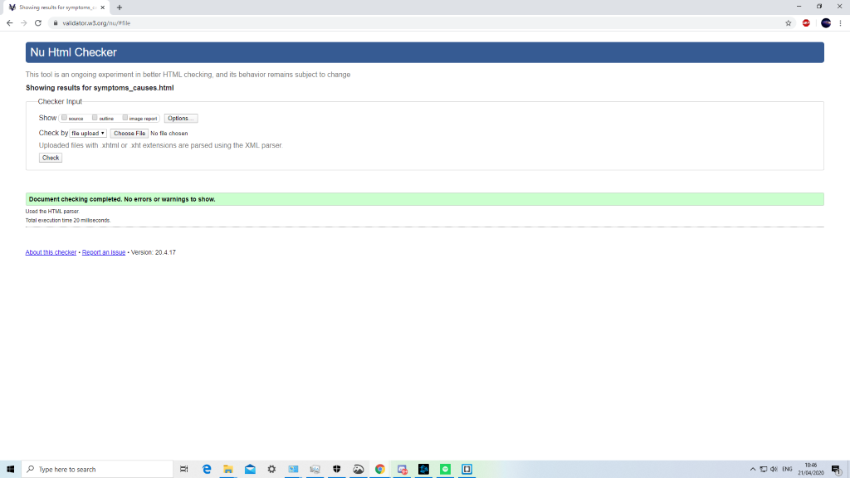

Page 3 – Validation result:

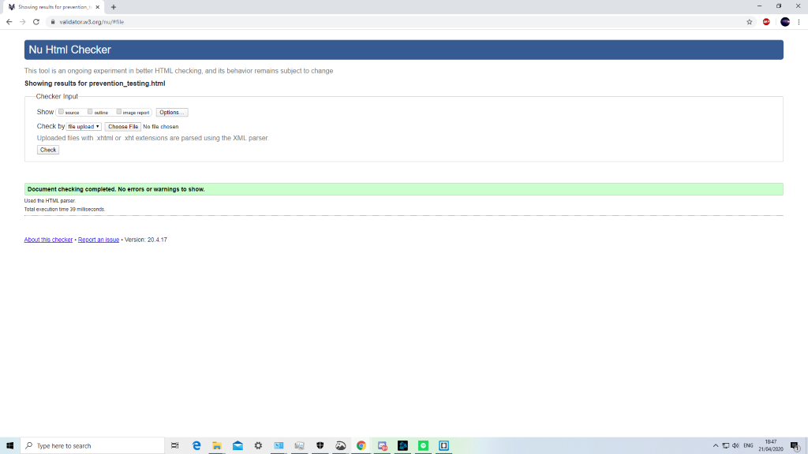

Page 4 Validation result:

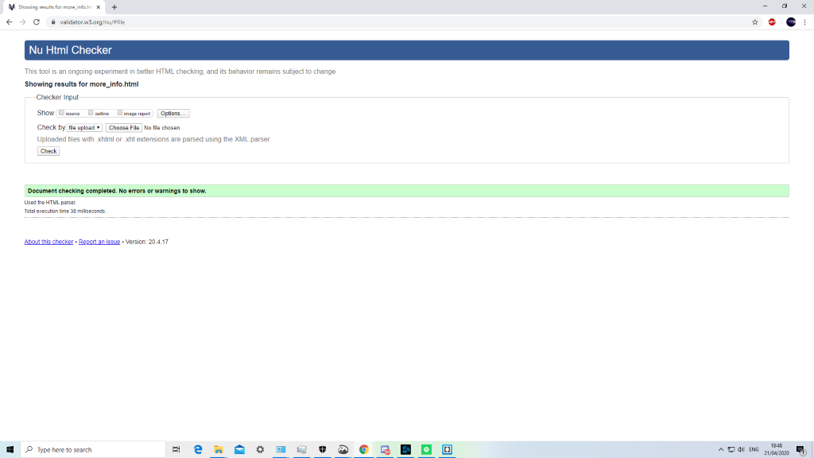

CSS Validation Results

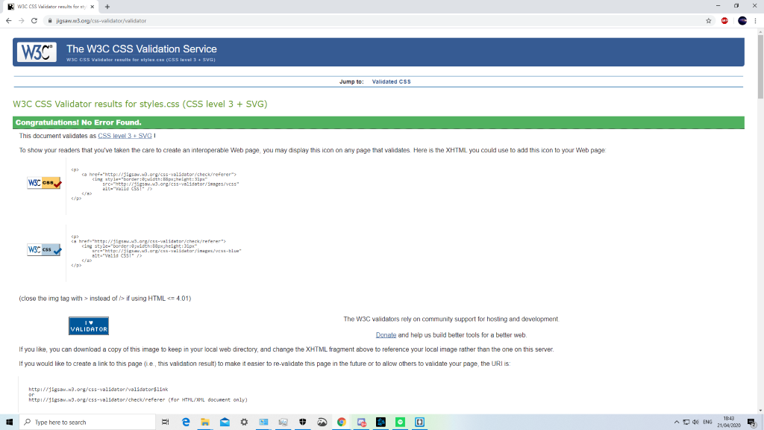

**You are asked to complete an original website of your own work; the website should contain the features listed below.**

Create a website using html5/CSS that will include the below Project Check List elements: if features are not obvious outline where they are located on the web page below. In order to mark the project, the student will present the website and explain the code, declaration of own work submitted.

|  |
| --- |
| **R ****Must include Report including purpose and intended audience of the website and sources of images and information of each web page and HTML & CSS validation results. Upload completed project include URL in report** |
| **R Minimum of 4 HTML Pages with navigation menu not dummy text, use text and hyper link from appropriate website (**outline college project on landing page, do not include any personal or college information in the content of the pages) |
| **R Upload progress and completed website to your GitHub account** |
| **R HTML5 standards and recommended page layout structure** (header, main, aside, article, footer, etc) |
| **R Include appropriate Meta data – description & appropriate keywords etc to improve pages SEO** |
| **R Include font family for web page body** |
| **R Appropriate use of External Style Sheet – Recommended CSS (**standard for majority of your CSS) |
| **R Appropriate use of Internal & Inline Styling on HTML page** (one example of each)  Internal: Used on Page 2 for tables with opposite repeating colours  Inline: Used on Page 3 to make a 1px black border between the columns |
| **R Home page content aligned to each other and visually attractive** |
| **R Include navigation above fold and bottom of web pages- Indicate on navigation the current page** |
| **R Include both Class and ID as CSS Selectors**  Used on all pages for CSS Styling both ID’s for single items and classes for repeating items used examples can be found on all pages. |
| **R Consistency of design on all pages, use of fonts, colour etc** |
| **R Appropriate use of Headings (h1, h2, h3, h4)** |
| **R Appropriate use of Colours (test for colour blind users)** |
| **R Include an article or section with 2 or 3 columns** (by using appropriate CSS)  On page 3 (Guidelines), used Internal CSS on page to make equal height columns that scale with page size. |
| **R Include logo and display in header of page** |
| **R Clear, consistent and align content on all pages** (reference all sources)  All sources referenced above and with inline comments throughout code. |
| **R Include images (with at least one image floated with text alongside)**  **I**mage floated on page 1 (Overview) with information text alongside it. |
| **R Use of background image**  Background image on page 3 (Guidelines) with opacity set to 0.13 through internal styling so text is still visible |
| **R Include table of data/information only for statistical data**  Table of statistical data available on page 2 (Symptoms and Causes) |
| **R Include lists ordered or unordered (different shaped bullet points)**  Unordered list on page 3 (Symptoms and Causes) to list symptoms and causes of COVID-19. |
| **R Include a link to a suitable video and google map**  Link to suitable video on page 4 (More Info)  A map is used with on page 3 (Symptoms and Causes) using iframe to display it.  Another 2 maps are listed on page 4 (More Info) |
| **R Include a contact me form and include red * beside required/mandatory input fields** |
| **R Verify data collected on contact form, using get and data attached to URL** (Use the method get to display values entered on form will be appended to URL and passed to server <form action=" [http://year1.ccpdev.me/FormTest.php](http://year1.ccpdev.me/FormTest.php?fdf=fdsaf&fdsfs=hfdsahfkjhfa)" method="get"> |
| **R Footer information including Copyright© 2020 and navigation** |
| **R Internal anchor Links on one of the webpages**  Internal anchor links on Navigation Bar and Footer on all Webpages.  “Go to top of page” in purple on all pages to move to top of page. |
| **R External Link to external website**  External links on page 4 (More Info) and page 3 (Symptoms and Causes). |
| **R Any Additional Features included:** Equal Height columns on Page 3 using Internal Styling on Page that scal with page size. |
| **R Results included in report of HTML5 Validation (with majority of issues addressed)** |
| **R Results included in report of CSS Validation (with majority of issues addressed)** |
| **R Include Favicon on the Title tab** |
| **Guide line on Website appearance, design and Content** [**https://webdesignledger.com/10-signs-of-a-user-focused-design/**](https://webdesignledger.com/10-signs-of-a-user-focused-design/) |
| **R Guidelines on Website overall appearance & design** [**https://webdesignledger.com/20-dos-and-donts-of-effective-web-design/**](https://webdesignledger.com/20-dos-and-donts-of-effective-web-design/) |